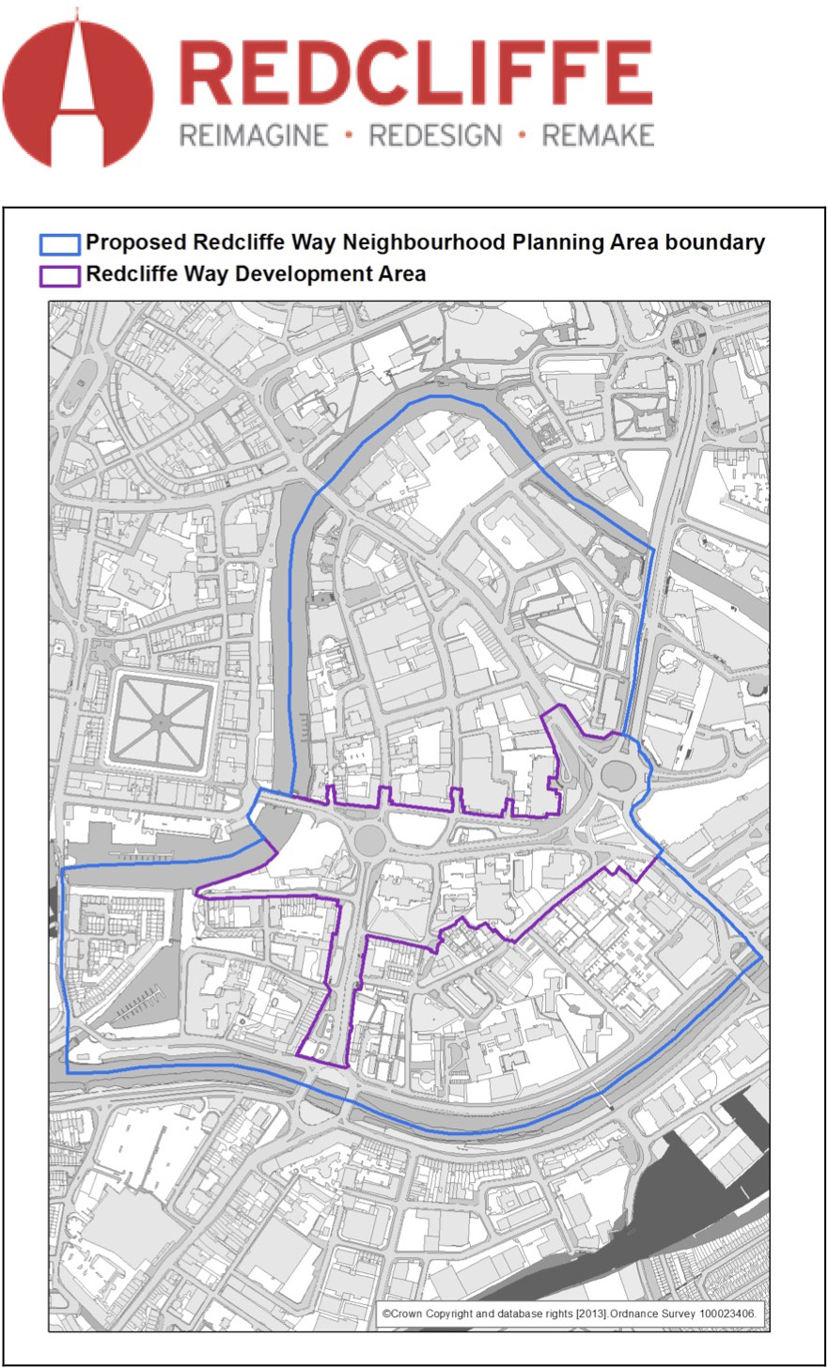
The Localism Act 2011 established the right of communities to prepare Neighbourhood Development Plans to respond to the needs of their local area and to create a genuine grassroots approach to setting planning policy. In 2012, the Government published the Neighbourhood Planning Regulations which set out the rules governing their preparation and adoption as statutory planning documents and how they must:
- Be compatible with European Union obligations and human rights requirements.
- Be in keeping with National Planning Policy Framework.
- Contribute to the achievement of sustainable development.
- Be in general conformity with the strategic policies of Bristol City Council’s Local Plan.
- The Bristol Local Plan comprises the Core Strategy, 1997 Plan Saved Policies, the
- Site Allocations and Development Management Policies and the draft Central
- Area Plan. These documents have all been referred to in preparation of this plan.

The Redcliffe Neighbourhood Plan (The Plan) sets out a vision and policies on the future development and use of land within Redcliffe. It focuses on the area around Redcliffe Way and Redcliffe Hill, as the key development areas for reconnecting North and South Redcliffe and creating a new heart and shared space for the neighbourhood.

Following the preparation of the draft Plan by The Forum, the draft Plan will undergo further statutory consultation led by Bristol City Council. Following this process it will undergo an independent examination and then a public referendum.

Once adopted at referendum, this Plan will stand alongside the Bristol City Council Local Development Framework and Adopted Core Strategy to guide development within the neighbourhood.

A Joint Delivery Board has been established between Redcliffe Forum and The Council to implement the Plan. The Plan will be a proactive tool used to implement positive change in the area. The Plan covers a period from 2015 to 2030.

